

THE ASSOCIATED STUDENTS OF COLORADO STATE UNIVERSITY

Xst SESSION OF THE FIFTY-FIFTH SENATE

Month/ Day/ Year

BILL #55##

Funding Safety Equipment for the Student Education Garden

NOTICE: A signature to sponsor means that you only wish for the legislation to be heard, a signature to endorse means that you support the contents and/or actions of this legislation.

WRITTEN BY: Cate Collins, Director of Environmental Affairs

COLLABORATED WITH: Mark Uchanski, Associate Professor, Vegetable Crops Program Coordinator, Department of Horticulture and Landscape Architecture

SPONSORED BY:

ENDORSED BY: Trina McDowell, Deputy Director of Sustainability

ABSTRACT: This legislation requests $2,982 from Senate Discretionary to support essential safety upgrades, equipment repairs, and operational improvements at the Student Education Garden (SEG) at Colorado State University. Investing in these upgrades will enhance safety, support hands on learning and research, and strengthen a widely used and growing university resource.

WHEREAS (1),

SEG currently relies on tools and implements representing tens of thousands of dollars in donated equipment, however, many items now require updates to ensure they remain safe, reliable, and appropriate for student and staff use.

WHEREAS (2),

SEG is a heavily used instructional and community space. Formal academic use includes HORT 451, SOCR 343 (22 students enrolled for Fall 2025), and HORT/SOCR 345 while additional engagement comes from stream ecology and entomology courses, research groups, and student organizations such as the Apiculture Club, Veterinary Club, and Student Gardening Club. SEG also serves Aggie Village residents with 74 community plots.

WHEREAS (3),
The site supports research conducted by multiple principal investigators including Doctors Uchanski, Miller, Burcham, Mason, and Lentz and their respective undergraduate assistants and research staff.

WHEREAS (4),
SEG sees 50–100 daily visitors due to the adjacent bike trail. In total, approximately 315 individuals engage with the SEG annually, with the potential to reach 600+ users within five years.

WHEREAS (5),
It is critical that additional safety equipment be funded for this multi-use area to adequately protect the health and safety of all employees, visitors, students, and researchers who engage with the Student Education Garden.

WHEREAS (6),
Item | Quantity Needed | Cost Per Item | Total Expense
Metal Arms (Bedder) ₁ | 2 | $30.00 | $60.00
Bolt Assembly ₁ | 1 | $12.00 | $12.00
Tachometer Sensor (Tractor) ₂ | 1 | $45.00 | $45.00
3-Point Quick Hitch (Tractor) ₂ | 1 | $490.00 | $490.00
Repair of King Kutter 3-Point Mower ₃ | 1 | $120 | $120.00
Belt Cover RH ₄ | 1 | $220.19 | $220.19
Belt Cover LH ₄ | 1 | $220.19 | $220.19
Sprayer Parts ₅ | 1 | $30.00 | $30.00
Pressure Valve Regulator (Sprayer) ₅ | 1 | $50.00 | $50.00
Tiller Tine Set LH RH ₆ | 1 | $375.00 | $375.00
Labor + Shipping + Shop Miscellaneous  ₁₋₆ | N/A | N/A | $1320.00

WHEREAS (7),
All invoices were generated by His Will Services, Inc. This maintenance and repair company was selected by the Student Education Garden within the Department of Horticulture and Landscape Architecture after a thorough review of competitive pricing throughout the Fort Collins area and a trusted reputation of adequate service.

THEREFORE, BE IT HEREBY RESOLVED/ENACTED (1)

That $2,982 from the Senate Discretionary Fund be allocated to the Department of Horticulture and Landscape Architecture to be used for safety improvements to the Student Education Garden; and,

THEREFORE, BE IT HEREBY RESOLVED/ENACTED (2)

Funding would be allocated to the managing entity of the Student Education Garden within the Department of Horticulture and Landscape Architecture; and,

THEREFORE, BE IT HEREBY FURTHER RESOLVED/ENACTED (3)

Any unspent funds remaining by end of fiscal year 2026 will be returned to the Senate Discretionary Fund; and,

THEREFORE, BE IT HEREBY FURTHER RESOLVED/ENACTED (4)

That a copy of this legislation be forwarded to Amy Parsons, President, Colorado State University; Tony Frank, Chancellor, CSU System; Blanche Hughes, Vice President, Student Affairs; Ben Schrader, Director, Adult Leaner and Veteran Services, ASCSU Advisor; Duan Ruff, Director, Student Leadership Involvement and Community Engagement; Julia Pratt, Assistant Director for Student Government, Student Leadership, Involvement and Community Engagement; Farah Shah, ASCSU/SLiCE Accountant, Student Leadership, Involvement and Community Engagement; Ali Raza, Assistant Director of Involvement, Student Leadership, Involvement and Community Engagement, ASCSU Advisor; Elisa Randazzo, ASCSU Administrative Assistant; Warner College Council; Ag Council; College of Liberal Arts Representative Council; Natural Sciences College Council; College of Health and Human Sciences Dean’s Leadership Council; College of Veterinary Medicine and Biomedical Sciences College Council; College of Business Dean’s Student Leadership Council; Lisa Chandler, Assistant Director, Adult Leaner and Veteran Services; Kathleen Fairfax, Vice Provost, International Affairs, Colorado State University; Chad Hoseth, Assistant Vice Provost, International Affairs, Colorado State University; Greg Wymer, Director, International Student Scholars and Services; Mary Ann Lucero, Executive Director, Academic Advancement Center; Elizabeth Sink, Lead, Multifaith and Belief Initiatives; Gaurav Harshe, Interim Director, Asian Pacific American Cultural Center; John Miller IV, Director, Black/African American Cultural Center; Aaron Escobedo Garmon, Director, El Centro; Maggie Hendrickson, Director, Pride Resource Center; Tyrone Smith, Director, Native American Cultural Center; Imani Lindberg, Interim Director, Survivor Advocacy & Foundational Education Center; Justin Dove, Director, Student Disability Center;

PASSAGE AND ENACTMENT OF RESOLUTION/BILL/LEX 55XX

SESSION OF PASSAGE

Yays – Nays – Abstentions

ASCSU SPEAKER OF THE SENATE BROOKELYN REESE DATE

ASCSU PRESIDENT JAKYE NUNLEY DATE

RESOURCES:

All invoices for the requested safety equipment were prepared by His Will Services, Inc. Invoices 1–6, which include all requested items and associated costs (labor, shipping, shop charges, etc.), are provided below for review.
1: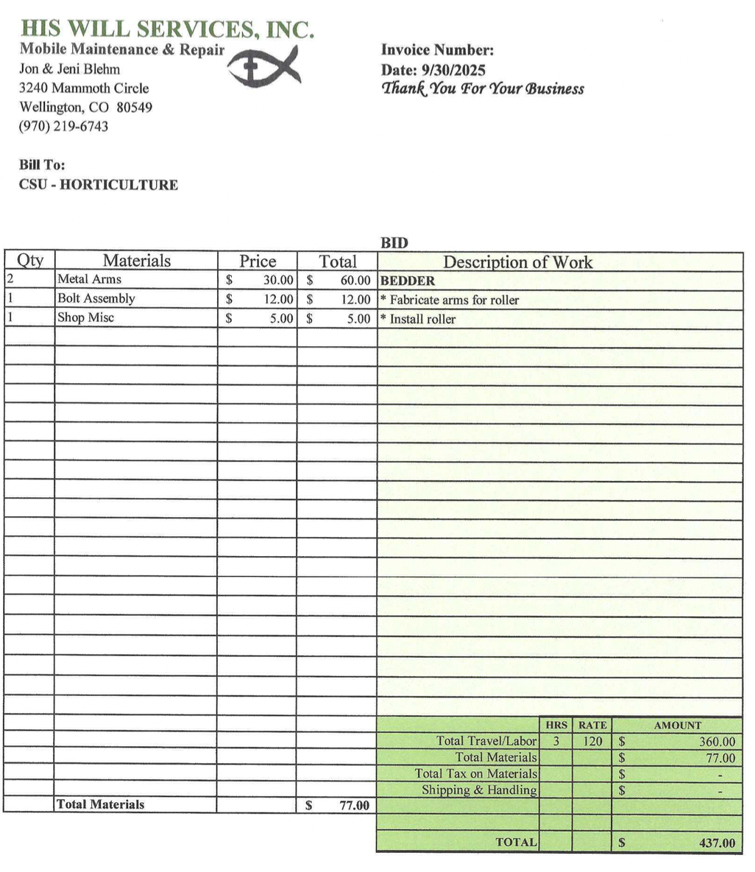
2: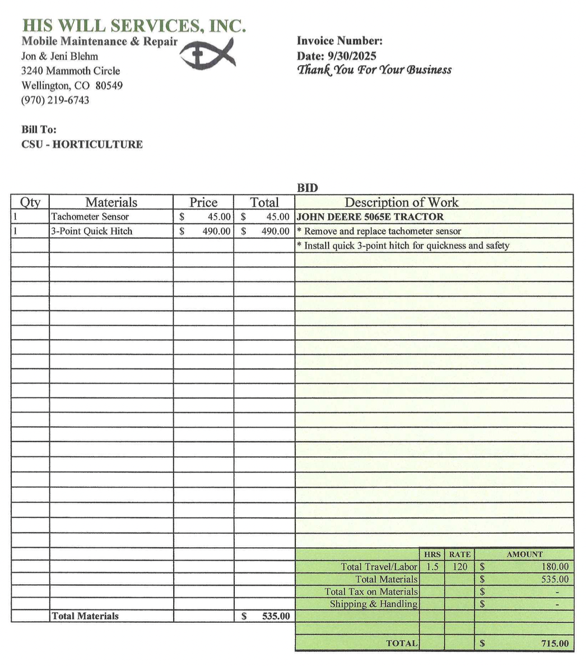
3: 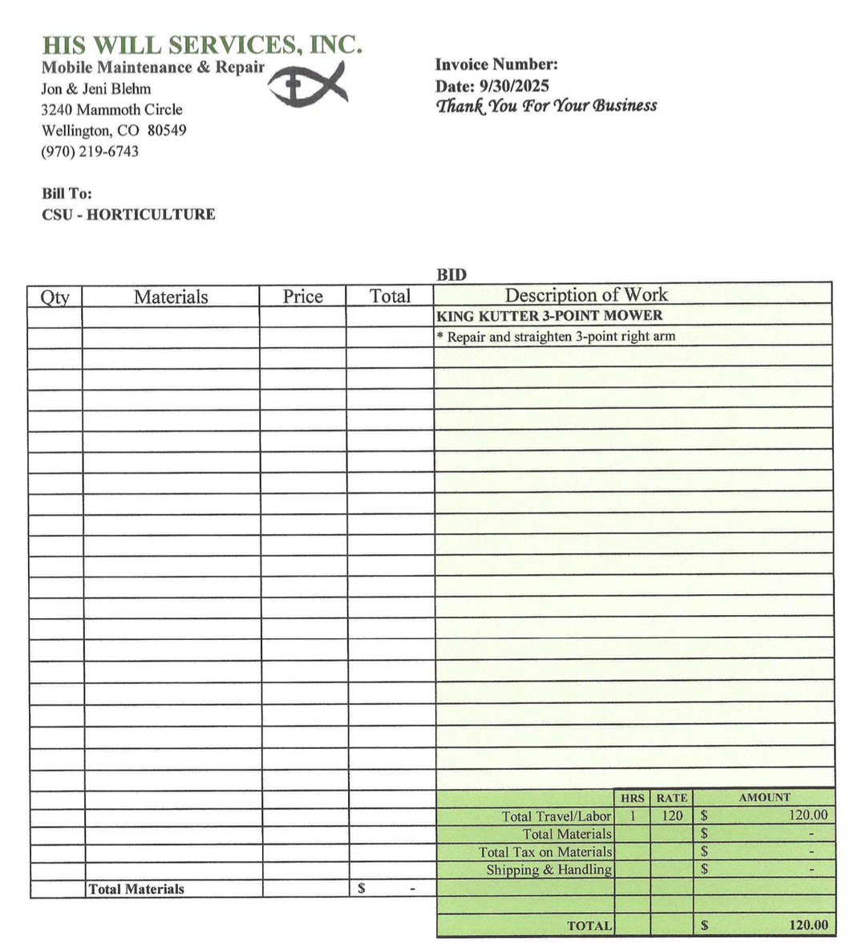
4: 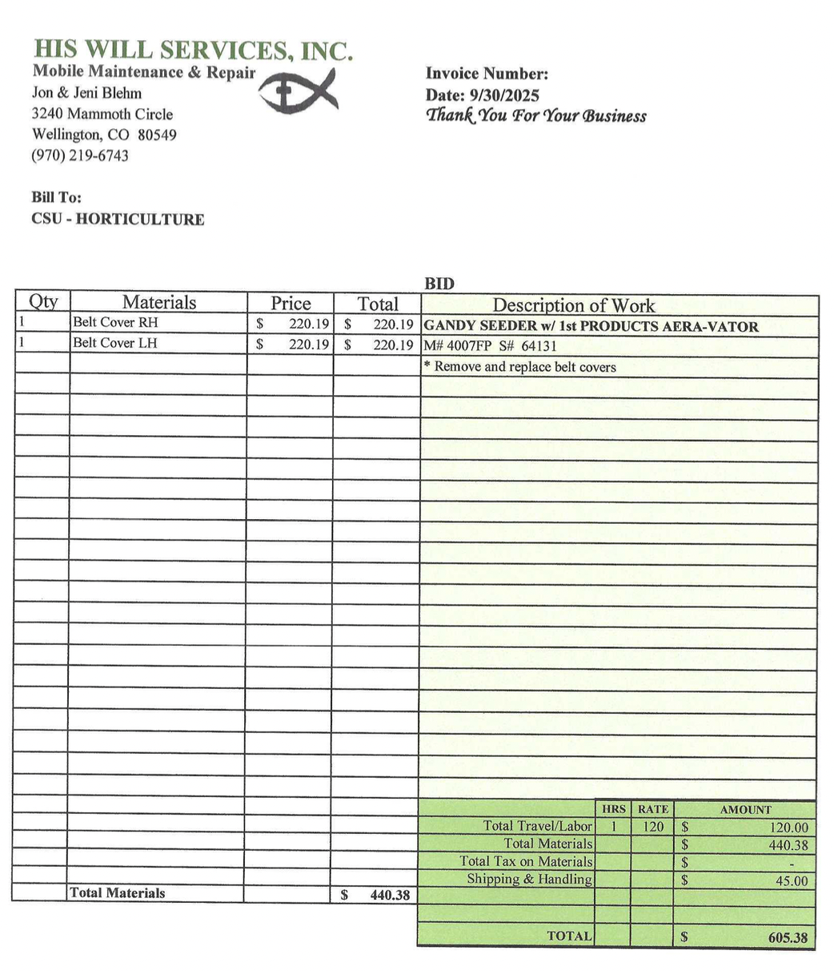

5: 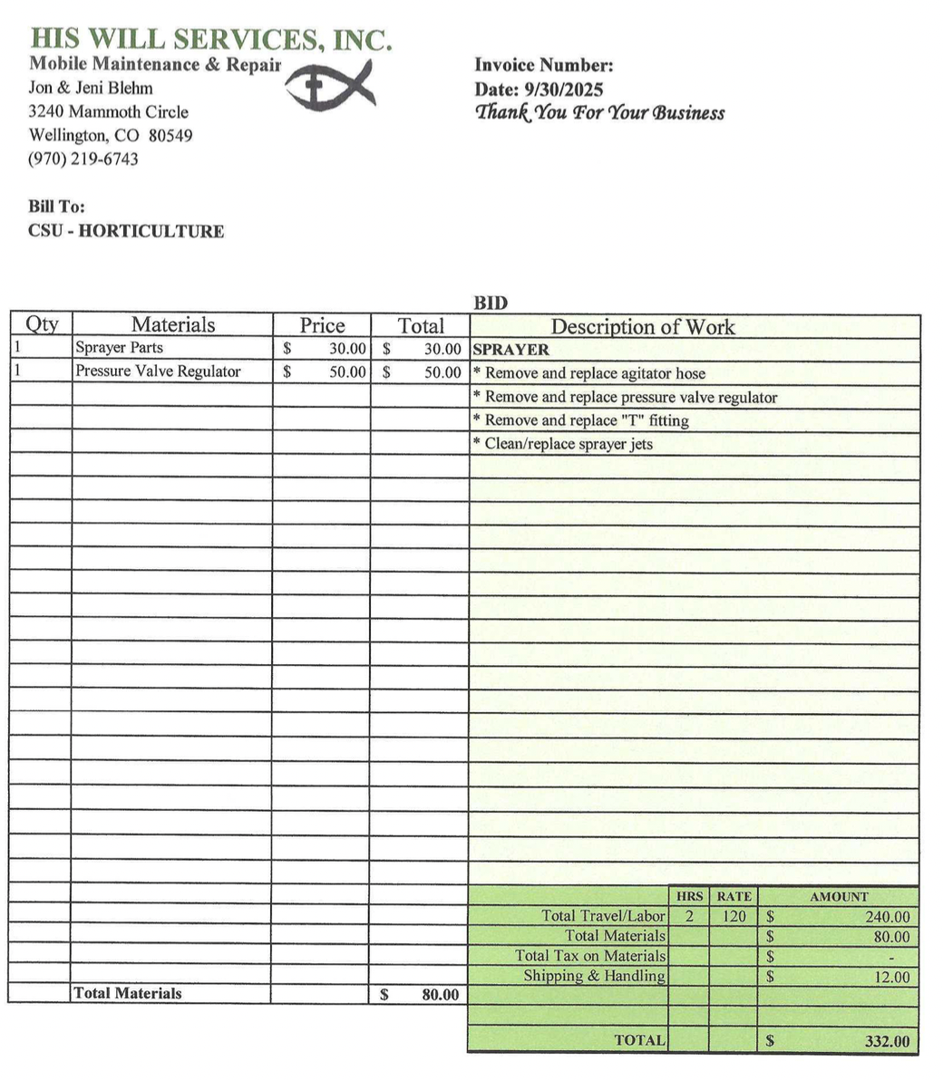
6: 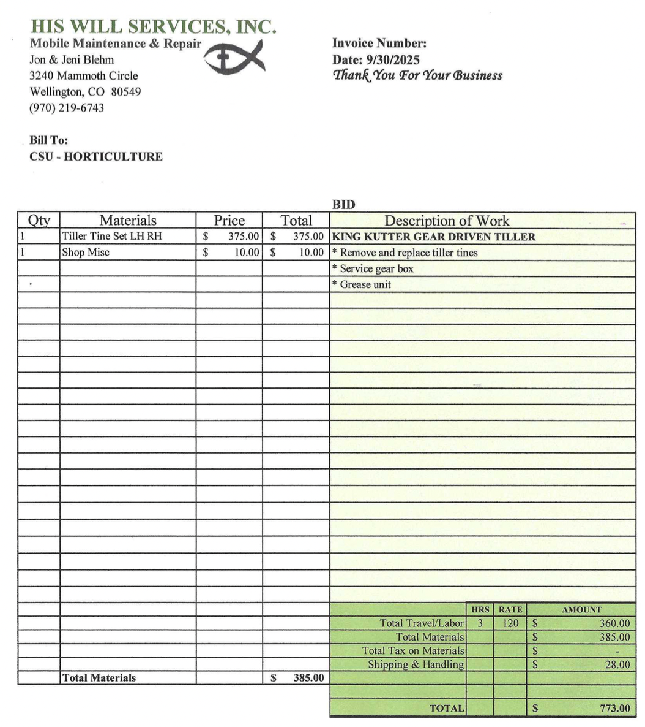

THAT THIS LEGISLATION SHALL BE FORWARDED TO:
Amy Parsons, President of Colorado State University
Tony Frank, Chancellor of the Colorado State University System
Blanche Hughes, Vice President for Student Affairs of Colorado State University
Ben Schrader, Director of the Adult Learner and Veteran Services, ASCSU Advisor
Julia Pratt, Assistant Director for Student Government of Student Leadership, Involvement and Community Engagement
Farah Shah, ASCSU/SLiCE Accountant for Student Leadership, Involvement and Community Engagement
Ali Raza, Assistant Director of Involvement for Student Leadership, Involvement and Community Engagement, ASCSU Advisor
Duan Ruff, Director of Student Leadership Involvement and Community Engagement
Elisa Randazzo, ASCSU Administrative Assistant
Warner College Council
Ag Council
College of Liberal Arts Representative Council
Natural Sciences College Council
College of Health and Human Sciences Dean’s Leadership Council
College of Veterinary Medicine and Biomedical Sciences College Council
College of Business Dean’s Student Leadership Council
Lisa Chandler, Assistant Director of Adult Leaner and Veteran Services
Kathleen Fairfax, Vice Provost of International Affairs for Colorado State University
Chad Hoseth, Assistant Vice Provost of International Affairs for Colorado State University
Greg Wymer, Director of International Student Scholars and Services
Mary Ann Lucero, Executive Director of the Academic Advancement Center
Elizabeth Sink, Lead of Multifaith and Belief Initiatives
Gaurav Harshe, Interim Director of the Asian Pacific American Cultural Center
John Miller IV, Director, Black/African American Cultural Center
Aaron Escobedo Garmon, Director of El Centro
Maggie Hendrickson, Director of the Pride Resource Center
Tyrone Smith, Director of the Native American Cultural Center
Imani Lindberg, Interim Director of the Survivor Advocacy & Foundational Education Center
Justin Dove, Director of the Student Disability Center

ARCHIVE INFO [Parliamentarian Use Only]

INTRODUCTION DATE/SESSION: ARCHIVE DATE:

COMMITTEE’S REVIEWED: MONETARY? Y/N

